Buckton Vale Primary School
Newsletter No10
Friday 12th November 2021

A message from Mrs Brown

It has been a very busy week at Buckton Vale and I am pleased to share with you some of the fantastic events the children have contributed to this week. I’m sure you will all agree the children have produced some wonderful art for our memorial garden. It was also wonderful to see so many children embrace the learning of their times tables whilst arriving in some wonderful outfits today. Thank you so much for your effort to promote times tables learning.

We have had some great feed back following the BBC news article which was aired last Friday Evening. People from outside the area have contacted school to see how they can donate. This is fantastic news.

Thank you to those who have taken time to view our new website and given feedback. If you have any ideas for further improvements please email the office on admin@bucktonvale.tameside.sch.uk Click this link to view the website http://www.bucktonvale.org.uk/

Thank you for your continued support
Mrs Brown

Stars of the Week
Stars of the week will still be announced in class every Monday, until we can resume the assemblies.
Reception Acorns | Georgia L
Year 1 Silver Birch | Ava W
Year 2 Sycamore | Freya L
Year 2 Beech | Aoife-Mae
Year 3 Hazel | Cal N
Year 3/4 Rowan | Sidney C
Year 4 Juniper | Laurence M
Y5 Maple | Reece B
Year 5/6 Oak | Myla A
Year 6 Cherry Blossom | Cerys M
Inspire Sports | Angel T
Important Dates Reminder
November
Friday 19th November Children in Need Non-Uniform Day (voluntary donations)
Friday 26th November School Christmas Fair 5pm to 7pm
December
Wednesday 1st December EYFS Nativity (Reception)
Tuesday 7th December KS1 Nativity (Yr1 & Yr2)
Wednesday 8th December Christmas Dinner – whole school
Thursday 9th December EYFS Party 1:30pm (Reception)
Friday 10th December KS1 Party 1:30pm (Yr1 & Yr2)
Monday 13th December Years 3 and Y4 Party (YEAR GROUPS)
Tuesday 14th December Years 5 and Y6 Party (YEAR GROUPS)
Tuesday 14th December Christmas Musical Evening (Partnership)
Wednesday 15th December Special Achievers Assembly 2.30pm
Friday 17th December Christmas Jumper Day (optional)
Friday 17th December School closes for Christmas Holiday
Remembrance Day

Many thanks to Mrs Thompson, Mrs Cherry & Mrs Aitken who have created a wonderful Remembrance garden using art work the children have created.

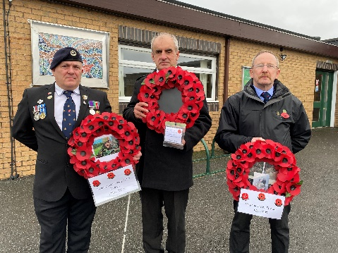
We also now have a permanent mosaic, donated by residents of the Crowswood Estate, to celebrate the life of Kingsman Sean Philip James Dawson, who sadly lost his life in Afghanistan.
We also want to say a special thank you to Mr. Thompson, who made the frame to display the mosaic, please take a moment to admire all the work as you pass.
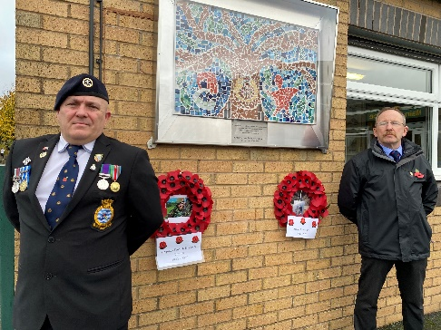
Mrs Thompson, Mrs Cherry and Mrs Aitken would like to thank everyone who contributed to this year’s garden.

We would also like to thank The British Legion, Tameside Councillor and Mr Frank Harrop & his wife for attending the school’s remembrance garden to lay wreaths for Kingsman Dawson and Corporal Joseph Etchells.
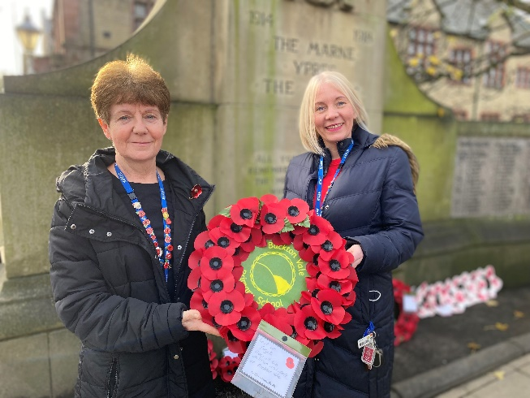
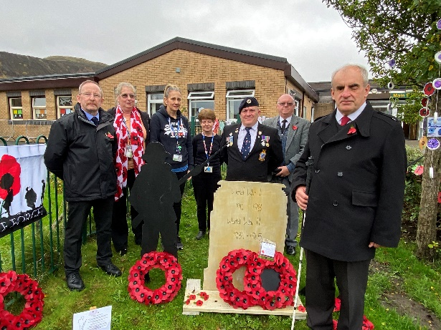

“I was impressed by all the efforts the children had made to mark the day and pleased that the tragic loss of two young men and former pupils, is not forgotten. I hope that it continues to bring some comfort to their families. The lead up to and the way in which the day was marked brings great credit to Buckton Vale Primary School”

Yours Sincerely, Councillor Adrian Pearce & Councillor Jan Jackson

TT Rock Stars
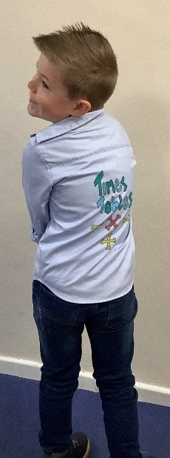
Well done to all the children who dressed up and took part in ‘England Rocks 2021’ learning our times tables.
I had a great morning celebrating our ‘Rock Legends’ and we were all extremely impressed with the many costumes the children came to school in. Everyone who took part has been presented with a certificate.
Well done Buckton Vale.
A big shout out must go to our 3 top players for the whole school.
1st place – Joseph H (Year 5)
2nd place – Faye B (Year 6)
3rd Place – Sam H (Year 5/6)
Remember to keep playing and keep learning. Many thanks to you all from Mrs Blake

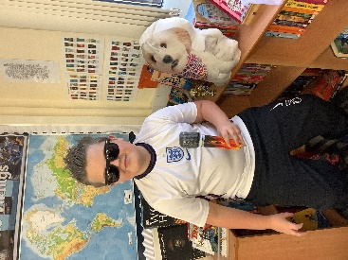
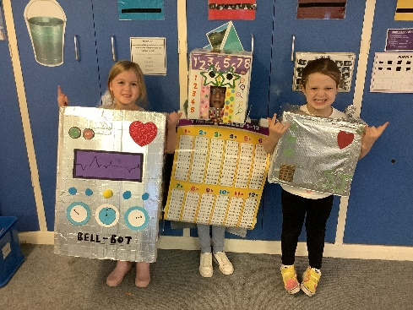
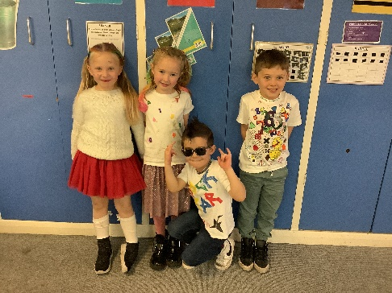

In the Spot Light

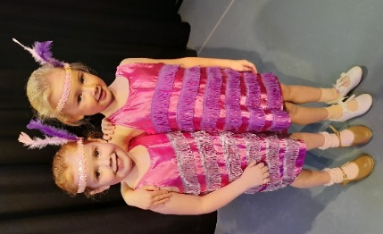
Elisabeth & Charlotte performed in their first dance show on Saturday, with the Sarah England School of Dance. All the children in the show were amazing and should be really proud of themselves for working so hard and performing so well.

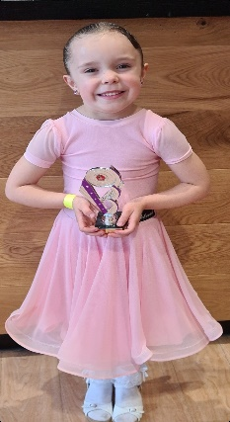

Grace competed in her first ever International Dance Ballroom and Latin dance on Sunday the 7th of November.
Not only did she qualify to dance/compete in Blackpool next Spring, she also was awarded 2nd place overall winner. She danced the waltz, Samba, Tango and Cha Cha Cha.

Amazing achievements by our children in KS1. Buckton Vale are so proud of you all.

Christmas & Half Term Club

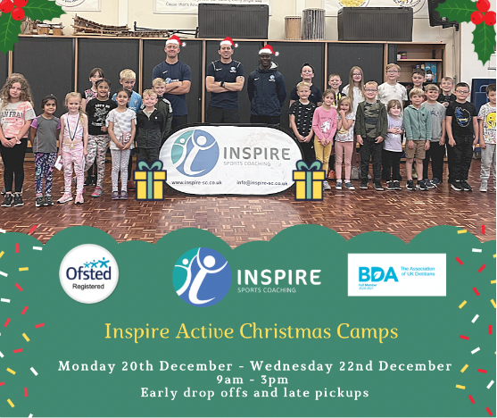
𝟰𝟱 𝗗𝗮𝘆𝘀 𝗧𝗶𝗹𝗹 𝗖𝗵𝗿𝗶𝘀𝘁𝗺𝗮𝘀 🎄😬
Christmas is just around the corner and this year the kids are breaking up early on 17th December 2021 which leaves over a week before the big day trying to juggle work, entertaining the children, getting those last minute presents sorted and much more I'm sure. 🎁
Let Inspire Sports Coaching LTD help you out with the childcare, due to a demand from parents and carers we have decided to run our 𝐎𝐅𝐒𝐓𝐄𝐃 𝐑𝐞𝐠𝐢𝐬𝐭𝐫𝐞𝐝 𝐈𝐧𝐬𝐩𝐢𝐫𝐞 𝐀𝐜𝐭𝐢𝐯𝐞 𝐂𝐚𝐦𝐩𝐬 from our base at
Buckton Vale Primary school.
🔸Monday 20th December - Wednesday 22nd December.
🔸Drop off from 9:00am and Pick Up at 3:00pm.
🔸Early drop offs and late pickups available
🔸 Sibling discount and Childcare Vouchers Accepted
If you would like to book please use the link below. 🏉🏀⚽️🎅🏾
https://inspire-sports-coaching.class4kids.co.uk

IMPORTANT - Time to Apply
Admission to Primary School – September 2022
If your child is due to start Primary School in September 2022, you will need to apply for a school place. As a Tameside resident, you should apply using the online application form, which is available on the School Admissions pages of Tameside’s website at the following address from 1st NOVEMBER 2021.

www.tameside.gov.uk/admissions

If you do not have access to the internet, all Tameside libraries have computers where you can use the internet free of charge for up to one hour per day.
The criteria by which places are offered and important information on the allocation process is available on the Tameside website. You are advised to read all the information on the “Starting Out” pages before you complete your online form.
The closing date for application forms is 15th January 2022. Any applications submitted after the closing date will be treated as ‘late’ and will not be processed until after those submitted on time.

Community News

